Pre-made enclosure

Otterbox/pelican enclosure

Can get an equivalent to wrap up electronics safely

Intermediary: designing and 3d printing a case - Dhruv

Advanced: own case – CNC, cast plastic

2 on software – electronics

2 on enclosure and attachment to nylon

Experiment design – metrics to deliver, reporting functionality, success criteria, statistics

Set high goals and fail spectacular – document why goals didn’t work

Toy fabrication – Nathaly (material, laser cutter, assemble/sew), electronics pocket

Electronics – Dhruv + Adithya (hardware + software) + Enclosure

Experiment design – Jacqueline

Base system – one of two ESPs

Computer logs serial data – can do in Arduino IDE—Cool Term

2 ESPs one on each side, each 1 IMU, 3rd ESP attached to computer to do data logging

Sew enclosure pockets and some Velcro top/close attachment; for otters wont work but generally fine for protoype – even binder clip/chip clip

Orientation for Craft lab on second floor – singer machines

Schedule an orientation

Ballistic nylon – laser cutter to sear edges and resize

Otter experimentation not realistic for this semester

IACUC – animal experimentation permission

Design experiments with intention to hand to otters

Will have time to experiment with dogs

To publish, need IACUC permission

28th – experiment

Time for data analysis

Quick research on sea kelp

Links dropped in chat:

<https://learn.sparkfun.com/tutorials/sending-sensor-data-over-wifi/all>

<https://protolab.gvu.gatech.edu/calendar>

<https://www.ulsinc.com/materials/ballistic-nylon>

As large as 2 ft a day

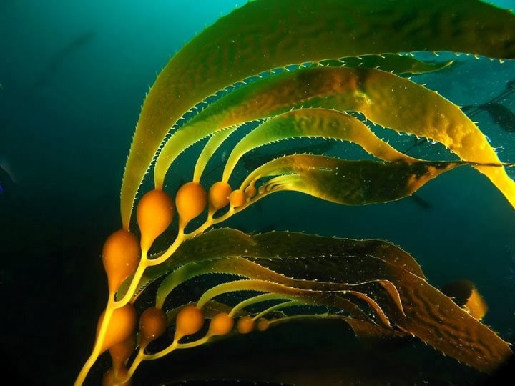

<https://www.ottoenvironmental.com/product/aussie-zoo-floating-artificial-kelp-2-sizes/> <https://www.ottoenvironmental.com/product/kelp-3/>

<https://en.wikipedia.org/wiki/Macrocystis_pyrifera#Description>

5.25 feet long